Copyright for test papers and marking guides remains with *West Australian Test Papers*.

* The papers may only be reproduced within the purchasing school according to the advertised conditions of sale.
* Test papers must be withdrawn after use and stored securely in the school until Friday 30 June 2017.

**HUMAN BIOLOGY**

**Unit 1**

**2016**



**ANSWERS**

**Note: This marking key has not been ratified so student responses outside those which have been provided can still be accepted if they are correct.**

**Time allowed for this paper**

Reading time before commencing work: ten minutes

Working time for the paper: three hours

**Materials required/recommended for this paper**

***To be provided by the supervisor***

This Question/Answer Booklet

Multiple Choice Answer Sheet

***To be provided by the candidate:***

Standard items: pens (blue/black preferred), pencils (including coloured), sharpener, correction fluid/tape, eraser, ruler, highlighters

Special items: non-programmable calculators approved for use in this examination.

**Important note to candidates**

No other items may be taken into the examination room. It is **your** responsibility to ensure that you do not have any unauthorised material. If you have any unauthorised material with you, hand it to the supervisor **before** reading any further.

**Structure of this paper**

|  |  |  |  |  |  |
| --- | --- | --- | --- | --- | --- |
| Section | Number of questions available | Number of questions to be attempted | Suggested working time (minutes) | Marks available | Percentage of examination |
| Section One  Multiple-choice | 30 | All | 30 | 25 | 30 |
| Section Two:  Short answers | 7 | All | 80 | 85 | 50 |
| Section Three:  Extended answers | 3 | 2 | 40 | 30 | 20 |
|  |  |  |  | **Total** | 100 |

**Instructions to candidates**

1. The rules for the conduct of the Western Australian Certificate of Education ATAR course examinations are detailed in the *Year 12 Information Handbook 2017*. Sitting this examination implies that you agree to abide by these rules.

2. Answer the questions according to the following instructions.

Section One: Answer all questions on the separate Multiple-choice answer sheet provided. For each question, shade the box to indicate your answer. Use only a blue or black pen to shade the boxes. If you make a mistake, place a cross through that square, then shade your new answer. Do not erase or use correction fluid/tape. Marks will not be deducted for incorrect answers. No marks will be given if more than one answer is completed for any question.

Section Two: Write your answers in this Question/Answer booklet. Wherever possible, confine your answers to the line spaces provided.

Section Three: Consists of three questions. You must answer two questions. Identify the question you are answering.

3. You must be careful to confine your answers to the specific questions asked and to follow any instructions that are specific to a particular question.

4. Additional working space pages at the end of this Question/Answer booklet are for planning or continuing an answer. If you use these pages, indicate at the original answer, the page number it is planned/continued on and write the question number being planned/continued on the additional working space page.

**Section One: Multiple-choice 30% (25 Marks)**

This section has **25** questions. Answer **all** questions on the separate Multiple-choice Answer Sheet provided. For each question shade the box to indicate your answer. Use only a **blue or black pen** to shade the boxes. If you make a mistake, place a cross through that square, do not erase or use correction fluid, and shade your new answer. Marks will not be deducted for incorrect answers. No marks will be given if more than one answer is completed for any question.

Suggested working time: 30 minutes.

1. Objectivity is a very important quality for a scientist. Which of the following best describes the difference between reliability and validity?
   1. **An experiment is valid if it tests what it is supposed to, whilst reliability is the extent to which an experiment produces the same result each time.**
   2. An experiment is reliable if it tests what it is supposed to, whilst validity is the extent to which an experiment produces the same result each time.
   3. Validity can be improved by performing the experiment on a large number of subjects at the same time, whilst reliability can be improved by repeating the experiment with a new set of equipment.
   4. Reliability is dependent on the number of uncontrolled variables, whilst validity is only dependent on the experimental variables.

**Use the following data, which shows the list of resting pulse rates of ten Year 11 Human Biology class members, to answer Questions 2 to 4.**

|  |  |  |  |  |  |  |  |  |  |
| --- | --- | --- | --- | --- | --- | --- | --- | --- | --- |
| 76 | 84 | 89 | 71 | 69 | 73 | 97 | 82 | 23 | 88 |

1. The mean pulse rate for the class is calculated to be
   1. 76
   2. **75**
   3. 23
   4. 73
2. The 9th student recorded a pulse rate of 23. What is the name given to such results that appear to be ‘abnormal’?
   1. Averages
   2. Mistakes
   3. **Outliers**
   4. Trials
3. Which of the following is the best way of presenting the data of the resting pulse rates?
   1. Line graph
   2. **Bar graph**
   3. Histogram
   4. Pie graph
4. Cells are small because as the size of a cell increases, the
   1. volume and surface area decrease.
   2. surface area and volume increase at the same rate.
   3. **volume increases at a greater rate than the surface area.**
   4. surface area increases at a greater rate than volume.
5. Cells of similar structure and function form
   1. specialised cells.
   2. **tissues.**
   3. organs.
   4. systems.
6. Osmosis is best described as
   1. the movement of both water and solutes from an area of low solute concentration to high concentration.
   2. the movement of solutes from areas of high solute concentration to low solute concentration.
   3. diffusion of water along the concentration gradient.
   4. **movement of water from an area of low solute concentration to high solute concentration.**
7. A microscope with a 10x ocular lens and 10x objective lens has a field of view of 2mm. What will the field of view be with a 4x objective lens?
   1. 0.5mm
   2. 2.5mm
   3. **5mm**
   4. 6mm

**Use the following diagram to answer Questions 9 to 11**

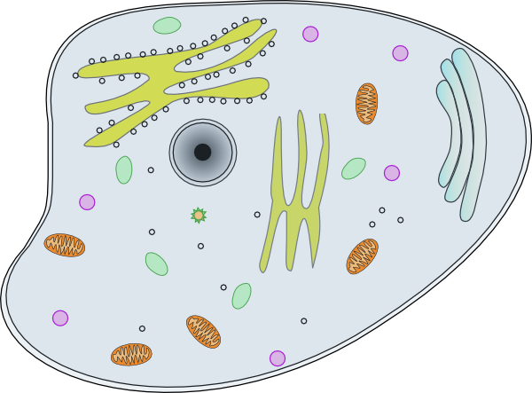

**F**

**E**

**D**

**C**

**B**

**A**

1. Which letter indicates the site where biosynthesis, processing and transport of proteins can occur?
   1. A
   2. B
   3. **C**
   4. D
2. What are the outputs of organelle B when oxygen is present?
   1. Carbon dioxide and nutrients
   2. Sugar and water
   3. Nutrients and energy
   4. **Water and carbon dioxide**
3. The process that occurs when organelle F fuses with the cell membrane and expels waste material is named
   1. **exocytosis.**
   2. pinocytosis.
   3. endocytosis
   4. phagocytosis.
4. Each kidney is composed of around 1 million functional filtration units. What is the name given to these functional units?
   1. Glomerulus
   2. Bowman’s Capsule
   3. Renal Corpuscle
   4. **Nephrons**
5. A high-protein diet will affect the production of urine by
   1. **increasing the volume of urine.**
   2. decreasing the volume of urine.
   3. not changing the volume of urine.
   4. increasing the concentration of urine.

**Use the table below that shows the stages and duration of an individual’s cardiac cycle to answer Question 14 and 15.**

|  |  |
| --- | --- |
| Stage | Duration (s) |
| Diastole | 0.3 |
| Atrial Systole | 0.2 |
| Ventricular Systole | 0.3 |

1. The heart rate of the individual is
   1. 52 beats per minute.
   2. **75 beats per minute.**
   3. 87 beats per minute.
   4. 100 beats per minute.
2. If the individuals stroke volume is 70mL, what is their cardiac output?
   1. 3640mL/min
   2. **5250mL/min**
   3. 6090mL/min
   4. 7000mL/min
3. What sign would a doctor find in a blood test if someone was suffering an allergic reaction such as hay fever?
   1. **Elevated white blood cell levels**
   2. Pain and excessive drainage of fluid from the lungs
   3. Increased heart and respiratory rate
   4. Increased levels of erythrocytes
4. Which of the following is an example of a catabolic reaction?
   1. Protein synthesis
   2. **Digestion of sugars**
   3. Glycogen formation
   4. DNA replication
5. The correct pathway of air into the lungs is
   1. **Nose, pharynx, larynx, trachea, bronchi, bronchioles, alveoli.**
   2. Nose, larynx, pharynx, trachea, bronchi, bronchioles, alveoli.
   3. Nose, pharynx, larynx, trachea, bronchioles, bronchi, alveoli.
   4. Nose, larynx, pharynx, trachea, bronchioles, bronchi, alveoli.
6. Which of the following bones is associated with the axial skeleton?
   1. **Skull**
   2. Pelvic Girdle
   3. Phalanges
   4. Fibula
7. Ammonia is converted to urea for excretion in the urine because
   1. ammonia is too large to enter the kidneys.
   2. urea is too large to remain in the body.
   3. **ammonia is more toxic than urea.**
   4. urea is more toxic than ammonia.
8. Which of the following nutrients are not absorbed in the large intestine?
   1. Water
   2. Vitamin K
   3. Vitamin B
   4. **Protein**
9. Which of the following muscle types are striated and voluntary?
   1. Cardiac muscle
   2. **Skeletal muscle**
   3. Smooth muscle
   4. Skeletal and smooth muscle
10. Bone and cartilage share many functions. Which of the following is a function of bone but not of cartilage?
    1. Movement
    2. Protection
    3. Support
    4. **Mineral storage**

**Use the information in the table below to answer Questions 24 – 25.**

A number of cells were obtained and placed in a nutrient medium to allow growth. The table below shows the composition and concentration of the cell’s cytoplasm and nutrient solution.

|  |  |  |
| --- | --- | --- |
| **Substance** | **Cytoplasm (g/L)** | **Nutrient Solution (g/L)** |
| Chloride | 32 | 15 |
| Potassium | 27 | 3 |
| Sodium | 42 | 44 |

1. The nutrient solution is
   1. **hypotonic.**
   2. isotonic.
   3. exotonic.
   4. hypertonic.
2. The movement of water (osmosis) would be
   1. from the cell to the nutrient solution.
   2. **from the nutrient solution to the cell.**
   3. non-existent.
   4. from the cell to the cytoplasm.

**Section Two: Short answer 50% (85 Marks)**

This section has **seven (7)** questions. Answer **all** questions. Write your answers in the spaces provided.

Spare pages are included at the end of this booklet. They can be used for planning your responses and/or as additional space if required to continue an answer.

* + Planning: If you use the spare pages for planning, indicate this clearly at the top of the page.
  + Continuing an answer: If you need to use the space to continue an answer, indicate in the original answer space where the answer is continued, i.e. give the page number. Fill in the number of the question(s) that you are continuing to answer at the top of the page.

Suggested working time: 70 minutes.

**Question 31 (15 marks)**

The human body consists of complex systems that work together to maintain life.

* 1. List the two body systems that bone marrow is associated with.

(2 marks)

**Circulatory System and Musculoskeletal / Skeletal System**

* 1. Name the two different types of bone marrow and describe the location and function them in relation to the body systems answered in question (b) above.

(6 marks)

**Red bone marrow (1) found in epiphysis of bones (1) and produces red blood cells (1).**

**Yellow bone marrow (1) found in diaphysis of bones (1) and is used for fat storage (1).**

Each cell is surrounded by a cell membrane that separates the cell contents from the external environment. Refer to the diagram below to answer the following question.

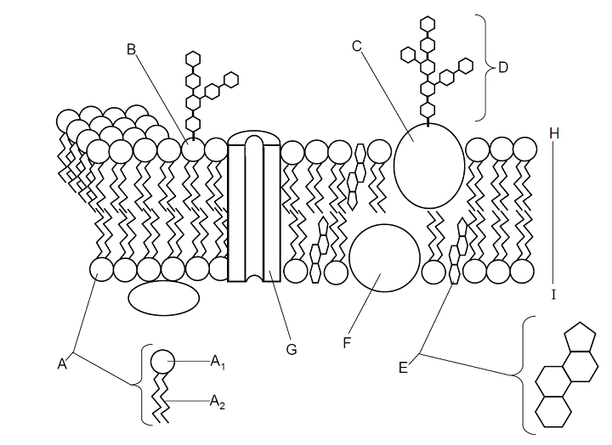

* 1. Name the molecules represented by the following structures.

(3 marks)

A1 **Hydrophilic Head / Phosphate Head**

A2 **Hydrophobic / Fatty Acid Tail**

G **Protein Channel**

The graph below shows the rate of uptake of two solutes.

**Solute A**

**Solute B**

* 1. State which type of transport is represented by each solute and give an example of a material that moves by this method. (4 marks)
     1. Solute A

**Diffusion - Water / oxygen / carbon dioxide / alcohol / fatty acids / steroids / ions including sodium, potassium, calcium / lipids / soluble drugs**

* + 1. Solute B

**Facilitated Diffusion / Carrier Mediated – glucose / amino acids**

**Question 32 (15 marks)**

The respiratory system allows for the exchange of gases between the internal and external environments.

1. Alveoli increase the surface area of the lungs to allow for diffusion. Name two other structural features of the lungs that assist in diffusion. (2 marks)

**Any two of the following for 1 mark each:**

**Well supplied with blood / blood vessels (accept continuous blood flow)**

**Thin membranes of capillary / alveolus (accept short diffusion pathway)**

**Layer of moisture / positioned deep within the body to prevent evaporation**

Whilst exercising it is important the body receives adequate amounts of oxygen, otherwise fatigue may occur.

1. Briefly explain the mechanics of breathing that allow the lungs to fill with air during exercise.

(3 marks)

**Any 3 of the following for 1 mark each:**

**Diaphragm / Intercostal muscles contract / flatten**

**Lungs / Ribs are pulled upwards and outwards**

**Volume of lungs / size of chest / thoracic cavity increases**

**Pressure within lungs are reduced**

**Air moves in to lungs**

1. Explain the process of oxygen and carbon dioxide diffusion between the alveolus and capillaries in the lung of a person at rest. (4 marks)

**Any four of the following:**

**Diffusion requires differences in concentration gradient (1)**

**Oxygen concentration is higher in alveolus (1)**

**and therefore will move from alveolus to capillary (1)**

**Carbon dioxide concentration is higher in capillary (1)**

**and therefore will move from capillary to alveolus (1)**

Aerobic respiration is a metabolic process that occurs in many small steps controlled by specific enzymes.

1. In aerobic respiration, how many ATP molecules are produced from one molecule of glucose. (1 mark)

**36-38 ATP**

1. State the location/s that aerobic respiration occurs in. (2 marks)

**Cytoplasm and Mitochondria**

1. Many enzymes are involved in the different steps of aerobic respiration. Explain the specificity of enzymes to their substrates.

(3 marks)

**Lock and key theory (1)**

**Enzyme has a specific active site (1) that is complementary to a specific substrate (1)**

**Question 33 (10 marks)**

An accident occurred in which a man severed a main artery in his leg and was taken to hospital.

1. Describe two structural differences between a vein and an artery. (2 marks)

**Two of the following pairs (must compare artery to vein) for 1 mark each:**

|  |  |
| --- | --- |
| **Vein** | **Artery** |
| **Thin** | **Thick** |
| **Non-elastic walls** | **Elastic Walls** |
| **Not muscular** | **Muscular Walls** |
| **Valves often present** | **No valves** |

Once cut, the body’s external defence systems are open to micro-organisms. As micro-organisms may cause disease, these must be destroyed and removed.

1. State the name of the cells specifically responsible for the destruction and removal of microorganisms. (1 mark)

**Phagocytes / Macrophages**

1. Explain why lymph nodes of the immediate areas surrounding the cut may swell and feel tender and sore. (2 marks)

**Lymph tissue contains lymphocytes/macrophages/phagocytes (1)**

**Increased number of these cells causes swelling/tenderness (1)**

The man has blood type O and required a blood transfusion.

1. Explain why the man can only receive blood from an O-type donor.

(3 marks)

**RBC’s of O-type do not have antigens present on cell (1)**

**Plasma of O-type has antibodies for both A and B antigens (1)**

**If RBC/blood with A / B / AB antigens is present, O-type plasma antibodies will destroy the donated blood (1)**

**Question 34 (13 marks)**

Once ingested, food passes through the alimentary canal and is digested.

1. Explain how the structure of the small intestine, is well adapted to absorb nutrients. (4 marks)

**Long / 6m / large surface area / inner lining is folded**

**Villi / finger-like projections are present (1)**

**Microvilli on cells are present (1)**

**Thin membrane for easier diffusion (1)**

Once absorbed, these nutrients are further broken down within the body.

1. State the name given to the breakdown of proteins. (1 mark)

**Deamination (also accept catabolism)**

Proteins, and their substrates, can be removed from the body via the kidney.

1. On the diagram below:
   1. Label the glomerular capsule, distal convoluted tubule and collecting duct
   2. Identify an area of filtration, an area of secretion and an area of reabsorption.

(6 marks)

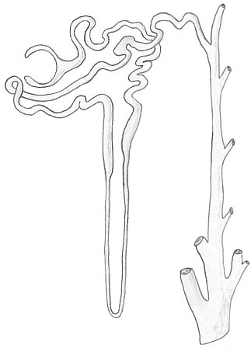

**Reabsorption at any of the following: PCT, DCT, LoH, Collecting Duct**

**Secretion at any of the following: PCT, DCT**

**Collecting Duct**

**DCT**

**Glomerular Capsule**

**Filtration**

Not all wastes are removed from the body in this way.

1. Describe the difference between elimination and excretion of wastes. (2 marks)

**Excretion is the removal of metabolic wastes from the body (1)**

**Elimination is the removal of indigestible foods / defecation (1)**

**Question 35 (17 marks)**

The diagram below shows the hip joint, with the head of the femur (3) connecting to the pelvis (6).

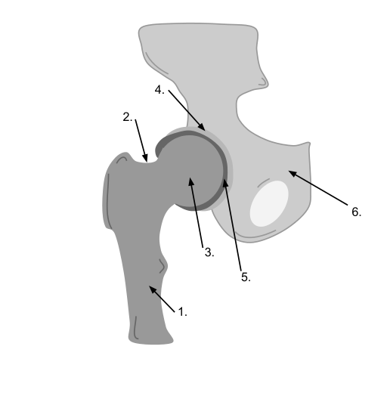

1. State the name and function of the cartilage found in locations 4 and 5. (2 marks)

**Articular Cartilage (1)**

**Provide a smooth surface for movement / reduce friction in movement (1)**

1. Fill in the table below stating the structure and movement of a fibrous and cartilaginous joint. (4 marks)

|  |  |  |
| --- | --- | --- |
| Type of Joint | Structure | Movement |
| Fibrous | **Fibrous tissue holds bones in place (1)** | **Immoveable / Fixed / No movement (1)** |
| Cartilaginous | **Bones held in place by cartilage (1)** | **Slightly moveable (1)** |

The movement of limbs around synovial joints are limited due to ligaments and attachments to the local muscles.

1. Describe two ranges of motion that can occur at the hip joint. (4 marks)

**Any two of the following. 1 mark for type of motion, 1 mark for description.**

* **Flexion: decreases angle between articulating bones**
* **Extension: increases angle between articulating bones**
* **Abduction: movement away from the midline of the body**
* **Adduction: movement towards the midline of the body**
* **Rotation: movement along the long axis of a bone**

**Question 36 (20 marks)**

Hydrogen peroxide (H2O2) is an unstable compound, decomposing to water and oxygen. Under normal conditions, the decomposition occurs very slowly. When yeast, which contains the enzyme catalase, is added, the reaction occurs faster. The table below shows the data collected during the experiment.

|  |  |  |  |  |
| --- | --- | --- | --- | --- |
|  | **Volume of Gas Collected (cm3)** | | | |
| **Temperature (ᵒC)** | **Trial 1** | **Trial 2** | **Trial 3** | **Average** |
| 20 | 8 | 8 | 8 | **8** |
| 30 | 38 | 41 | 37 | **39** |
| 40 | 49 | 54 | 57 | **53** |
| 50 | 35 | 31 | 34 | **33** |
| 60 | 12 | 11 | 12 | **12** |

1. Calculate the average volume of gas collected for each temperature. (5 marks)
2. State why multiple trials of the experiment are undertaken. (1 mark)

**Improves the reliability of the experiment**

1. Identify the following variables:
   1. Independent variable (1 mark)

**Temperature in ᵒC (unit must be included)**

* 1. Dependent variable (1 mark)

**Volume of Gas Produced in cm3 (unit must be included)**

* 1. Two controlled variables (2 marks)

**Any two of the following or other appropriate variables:**

**Concentration of hydrogen peroxide**

**Time allowed for reaction to occur**

**Mass of yeast added**

**Volume of hydrogen peroxide**

1. On the grid paper provided, construct a graph that can be used to represent the data.

(5 marks)

If you wish to make a second attempt at this graph, extra grid paper can be found at the end of the examination booklet. Ensure you indicate this clearly.

**One mark for the following:**

**Appropriate title stating independent and dependent variables**

**Correctly labels axes with names**

**Labels axes with units**

**Uses correct type of graph**

**Plots data correctly**

1. State the optimal temperature for catalase activity.

(1 mark)

**40ᵒC**

1. Describe what occurs to catalase after the optimum temperature is reached.

(2 marks)

**Denatured (1)**

**Alters the active site (1)**

**Question 37 (6 marks)**

The various tissues of the human body can be categorised into four basic tissue types. In the table below, identify the tissue type and state the function of the tissue.

|  |  |  |
| --- | --- | --- |
|  | Tissue Type | Function |
| File:Simple columnar epithelial cells.png | **Epithelial** | **Covers / lines internal and external surfaces of the body** |
|  | **Nervous Tissue** | **Receives and transmits messages/impulses around the body** |
| C:\Users\alanak\Downloads\shutterstock_73097881.jpg | **Connective Tissue** | **Binds and supports other tissues** |

**Section Three: Extended answer 20% (30 Marks)**

This section contains **three (3)** questions. You must answer **two (2)** questions. Make sure you clearly indicate which question you are answering and write your answers in the space provided.

Responses could include clearly labelled diagrams with explanatory notes; lists of points with linking sentences; clearly labelled tables and graphs; and annotated flow diagrams with introductory notes.

Suggested working time: 40 minutes.

**Question 38 (15 marks)**

Every day we eat food and our bodies chemically breakdown these large molecules into smaller ones with the help of enzymes located in the alimentary canal.

1. Describe how the mouth, stomach and small intestine allows for the processes of mechanical and chemical digestion to occur. (10 marks)

**Any 10 of the following worth 1 mark each:**

**Action of the teeth / jaw break food into smaller pieces (1)**

**Mixes with saliva / amylase that breaks down starch molecules (1)**

**stomach lining produces gastric juice which contain enzymes (1)**

**stomach has three muscle layers / have circular, longitudinal and oblique muscles (1)**

**muscle constricts behind food and relaxes ahead (1)**

**occurs in waves / peristalsis (1)**

**stomach and intestine churns food in a variety of ways (1)**

**pepsin / gastric protease breaks down proteins / amino acids (1)**

**pepsin requires HCl acid to act (1)**

**bile salts as mechanical digestion to break up fats / emulsify fats (1)**

**intestine releases intestinal juices (1)**

**pancreas produces pancreatic juices (1)**

**enzymes include:**

**lipase that break down lipids/fats (1) 🡪 fatty acids + glycerol (1)**

**amylase that break down starch (1) to glucose (1)**

**protease that break down proteins (1) to peptides (1)**

**peptidases that break down peptides (1) to amino acids (1)**

**nucleases that break down RNA/DNA (1)**

Once broken down, the nutrient materials are absorbed through the membranes of the cells lining the intestine.

1. Compare and contrast facilitated diffusion and active transport. (5 marks)

**Both involve binding of a substrate to a carrier protein (1)**

**Facilitated diffusion is passive (1), with solutes moving down their concentration gradients (1).**

**Active transport requires ATP / energy (1), and moves solutes against their concentration gradient (1).**

**Question 40 (15 marks)**

The muscular system is organised to produce movement, such as when breathing.

1. Explain the sliding filament theory in relation to the microscopic structure of skeletal muscle. (10 marks)

**Any 10 of the following:**

* **Contains muscle fibres**
* **Muscle fibres consist of myofibrils**
* **Myofibrils consist of myofilaments**
* **Thick myofilament is myosin**
* **Thin myofilament is actin**
* **Myofibrils divided into sarcomeres**
* **Sarcomere consist of:**
  + **H zone – between ends of actin**
  + **A band – length of the myosin**
  + **I band – between ends of myosin of different sarcomere**
  + **Z line – where actin of different sarcomeres meet**
* **When muscles contract, sarcomere shortens / Z-lines are pulled closer together**
* **Thin filaments slide over thick filaments**
* **Cross bridges are formed between thin and thick filaments**
* **ATP is required**
* **Calcium and troponin is required to release tropomyosin**

**\*Appropriate labelled diagram to be accepted.**

1. Lifestyle choices can compromise our body’s function, such as breathing. Explain the effects that long-term smoking has on the respiratory system. (5 marks)

**Any 8 of the following:**

* **Alveoli is damaged (1)**
* **Alveoli / lung tissue lose elasticity (1)**
* **Fibrous tissue replaces elastic tissue (1)**
* **Internal surface area of the lungs is reduced (1)**
* **Lungs are constantly inflated (1)**
* **Breathing no longer is passive and requires voluntary effort (1)**
* **Emphysema occurs (1)**
* **Cilia is destroyed in respiratory tracts (1)**
* **Excess mucous is produced and cannot be removed (1)**
* **Smokers cough occurs to remove mucous (1)**

**Question 39 (15 marks)**

1. Draw and label the major structures of the heart, identifying the pathway of blood flow. (9 marks)

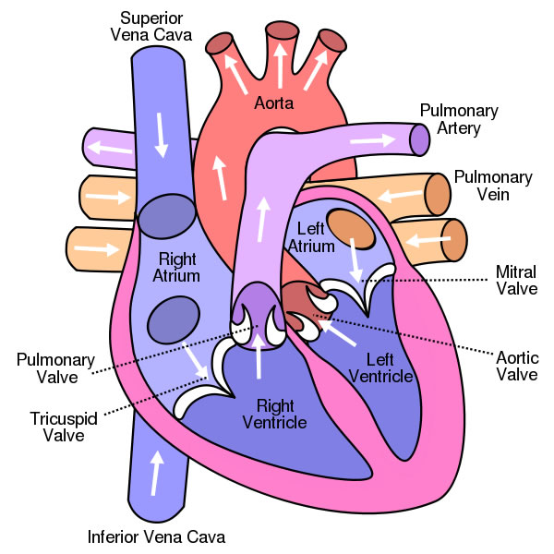

**7 of the following structures MUST be included**

* + **Right atrium (1) Right ventricle (1)**
  + **Left atrium (1) Left ventricle (1)**
  + **Aorta (1) Vena Cava (1)**
  + **Pulmonary artery (1) Pulmonary vein (1)**

**AND the correct pathway of blood (1)**

1. For efficient metabolism, cells require nutrients such as carbohydrates, proteins and lipids. Describe the structure and function of these three nutrients. (6 marks)

**2 marks for structure, 2 marks for function from each nutrient. Total 3 marks per nutrient**

|  |  |  |
| --- | --- | --- |
|  | **Structure** | **Function** |
| **Carbohydrate** | **Contain CHO (1)**  **Structural units are monosaccharides, disaccharides and polysaccharides (1)** | **Main energy source (1)**  **Excess stored as glycogen or converted to fat (1)** |
| **Proteins** | **Contain CHON (1) and sometimes S and P.**  **Amino acids are the basic structural unit (1)** | **Functions include catalytic / regulatory / movement / immunological / recognition / structural / transport (1)** |
| **Lipids** | **Contain CH and small amount of O (1)**  **Made up of glycerol and fatty acids (1)**  **Can be saturated, unsaturated and trans fats (1)**  **Can be high or low density (1)** | **Energy reserve (1)**  **Cell membrane / phospholipid (1)**  **Cholesterol (1)**  **Steroid hormone (1)** |

**ACKNOWLEDGEMENTS**

**Question 1**

Cell Diagram

<http://www.clker.com/clipart-animal-cell.html>

**Question 31**

**Diagram**

Membrane Transport

<http://cronodon.com/BioTech/Membranes.html>

**Question 34**

Nephron

**Question 35**

Hip Joint

https://commons.wikimedia.org/wiki/File:Ball\_and\_Socket\_Joint\_(Hip\_joint).svg#/media/File:Ball\_and\_Socket\_Joint\_(Hip\_joint).svg

**Question 37**

Cell Types

Diagram A

https://commons.wikimedia.org/wiki/

Diagram B

Shutterstock, copyright Alila Medical Media

Diagram C

Shutterstock, copyright lightspring.